FOR IMMEDIATE RELEASE
October 1, 2019

Cristy Armstrong
Touchpoint Communications
914.447.7619
cristy@touchptcom.com

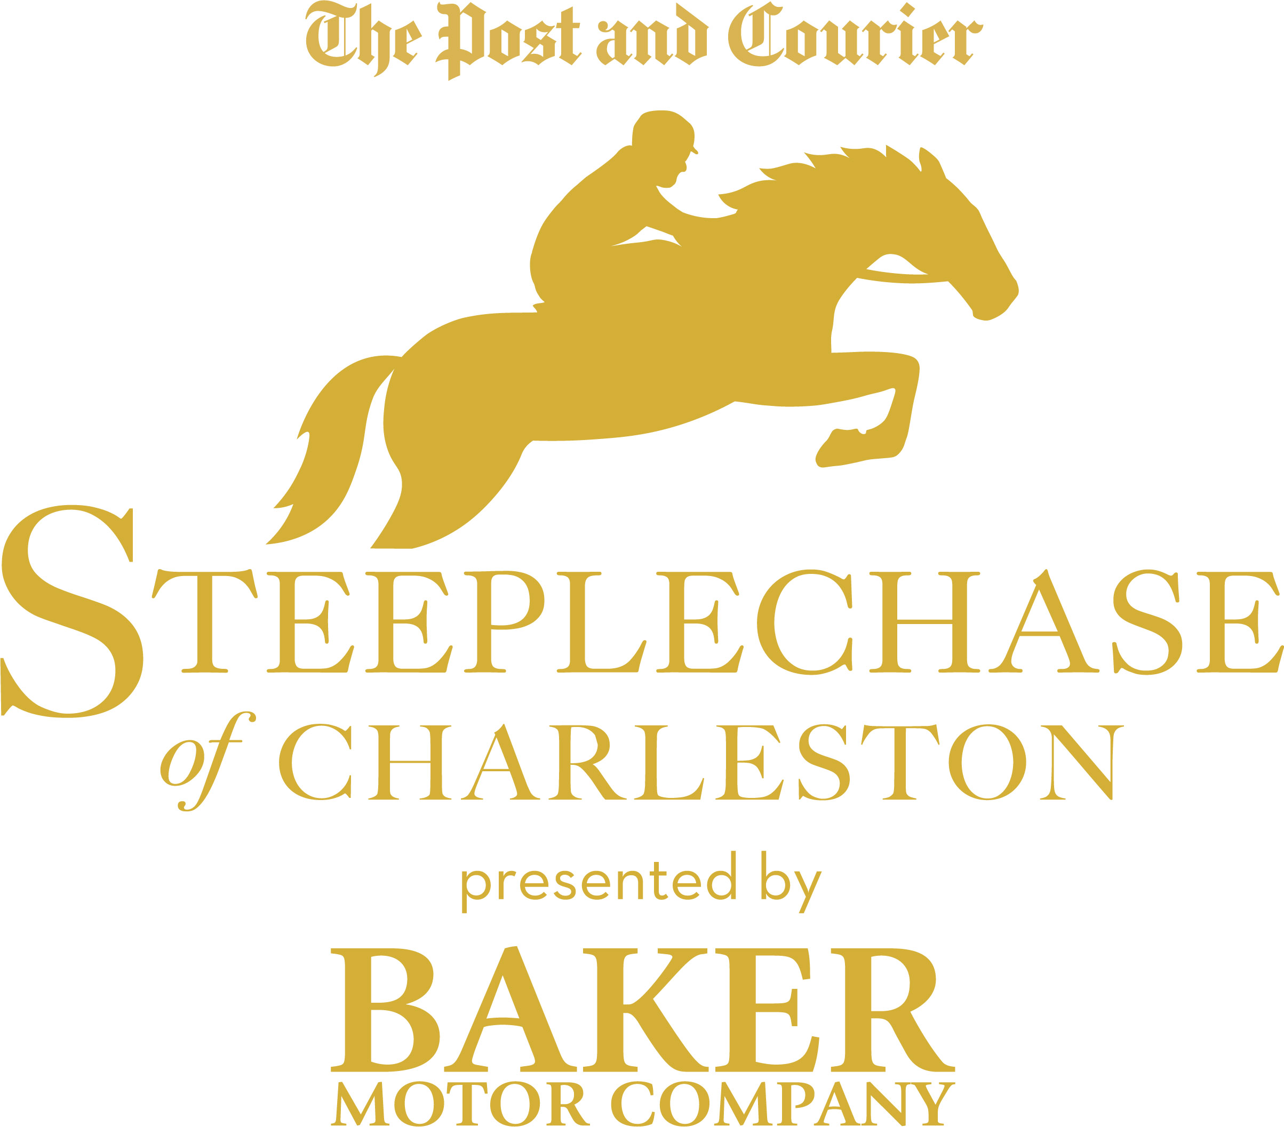

STEEPLECHASE SECURES PRESENTING SPONSOR BAKER MOTOR COMPANY;
RACE DAY PROMISES ELEVATED SOCIAL, MUSIC, FASHION EXPERIENCES

CHARLESTON, S.C. – Thousands of horse aficionados, spectators and local vendors will converge on The Plantation at Stono Ferry Racetrack on Sunday, November 17, 2019 for the Steeplechase of Charleston, presented by Baker Motor Company. This quintessential Southern event – sanctioned by the National Steeplechase Association – will deliver experiential fun with horse racing, tailgating, a parade of fashions, local vendors and live music.

Citing a day filled with five races, a main stage with rotating musical acts, competitive tailgating and more, P.J. Browning, publisher of event owner The Post and Courier, said: “Our aim is to make this a must-do regional event, and one that guests look forward to season after season.” Entertainment includes:

- Five high-stakes races for coveted titles and at least $70,000 in prize money.

- Grand Stage with rotating live music and fashion competitions:
  - Dillard’s will feature a Fashion Parade on Race Day - starting in the Tailgate area, traveling along Vendor Alley, onto the Grand Stage and completing its run in the VIP Chalet. This parade, featuring the latest fashions for the holiday/fall season, will showcase the retailer’s exclusive collections.
  - The Gaillard Center will showcase an art-inspired fashion show on the Grand Stage.
  - Race-goers are invited to participate in one of the five fashion contests taking place between races: Best dressed female, male, and family, as well as, craziest pants and most creative hat construction.

- The Family Zone will feature complimentary rides on Tabor Mortgage Group’s “Bird’s Eye View” Ferris wheel as well as activities and prizes for all ages.

- Bartles & Jaymes, the official wine cooler of the event, will welcome VIP Chalet ticketholders to its specialty lounge featuring a signature cocktail with appetizer pairings curated by Charleston’s own The Cocktail Bandits.

- The all-new Mystery Airdrop Giveaways will surprise a few race-goers with high-end prizes from official sponsors on race day via the airdrop function on their iPhones.

- The Vendor Village will feature local shops, regional food trucks and Lowcountry artisans just in time for holiday shopping.

A portion of proceeds will benefit The Post and Courier Foundation’s Good Cheer Fund, which helps support seven local organizations: Association for the Blind and Visually Impaired SC, Carolina Youth Development Center, Catholic Charities, the Lowcountry Food Bank, Salvation Army, Star Gospel Mission and the Charleston Leadership Foundation.

Guests can choose from many ticket options, from General Admission to VIP; obtaining a special Tailgate space is a preferred way for social and corporate groups to experience the event. Children 12 and under are free. Purchase tickets at steeplechaseofcharleston.com.

Attendees are encouraged to carpool or ride share to the event. A $60 round trip shuttle will run from The Post and Courier’s office downtown to the event. Tickets must be purchased ahead of time on the event website.

###

About Steeplechase of Charleston:
The Steeplechase of Charleston is an annual equestrian event, dating back to 1792. Produced by Evening Post Industries, the event closes out the National Steeplechase Association fall racing circuit with five races and at least $70,000 of purse money and national titles up for grabs.

